Greek and Latin in Scientific Terminology, Lecture 9

Andrew Dunning

5 August 2014

# Practice Test

## I. Translate

## ‘with’, ‘together’ + ‘flock’ + ‘having’, ‘having the shape of’, ‘characterized by having’

* con-greg-ate

## ‘before’, ‘in front of’ + ‘back’ + ‘pertaining to’, ‘like’, ‘belonging to’, ‘having the character of’

* ante-dors-al

## ‘apart’, ‘in different directions’, ‘thoroughly’ + ‘to turn’

* di-vert

## ‘hard’ + ‘able to be’, ‘able to’, ‘tending to’

* dur-able

## ‘to’, ‘toward’, ‘near’ + ‘to stick’ + ‘person who’, ‘that which’

* ad-HER-ent

## II. Interpret

## Prefixes

**Di**cynodonts are an **ex**clusively herbivorous clade of synapsids.

They **com**prise more than 100 species that are known from the Middle Permian the Late Triassic periods Dicynodonts were morphologically **dis**parate and **pre**sented a wide range of sizes and putative ecological niches, **in**cluding semi-aquatic, fossorial, arboreal and grazing.

**De**spite over 150 years of **di**cynodont research, several paleobiological aspects of the neuroanatomy, inner ear morphology and **inter**nal cranium anatomy remain practically **ob**scure.

Moreover, because the **de**structive technique of serial sampling was the primary way to access the **inter**nal anatomy of **di**cynodont skulls, the data available for various taxa was **in**consistent and rarely subjected to synthetic treatments.

As a **re**sult, details of **inter**nal skull anatomy have been overlooked in **re**cent phylogenetic analyses. Only Surkov and Benton **in**cluded a large number of braincase characters in a phylogenetic analysis of **di**cynodonts.

**Re**cent **ad**vances in non-destructive imaging techniques such as high resolution **com**puted tomography, neutron tomography, and synchrotron radiation based micro-computed tomography, hold the potential to **pro**vide significant new **in**sight **in**to fossil skull morphology. However, the **ap**plication of such techniques to **di**cynodonts has been limited.

## in

* 'into', 'on'

## de-

* ‘down’, ‘away’, ‘off’, ‘thoroughly’

## di-, dis-

* ‘apart’, ‘in different directions’, ‘thoroughly

## con

* ‘with’, ‘together’, ‘very’

## ex-

* ‘out’, ‘from’, ‘removal’, ‘completely’

## pro-

* ‘forward’, ‘in front of’

## Wood Roots

The sheep used in these **experiments** were cared as per outlined in the Guide for the Care and **Use** of **Animals** in **Agricultural** Research and Teaching **Consortium** [8]. Thirty **affected** and 30 **unaffected** sheep were slaughtered with **electrical** stunning then **exsanguination** ....

The **study** **area** was located in a region **adjoined** by the **provinces** of Guizhou, Yunnan, and Sichuan (26°56'-27°47' N, 103°56'-104°51' E), with the average **elevation** 2100 m above the sea **level**, the **annual** **precipitation** 956 mm, and the average **atmospheric temperature** 9–11°C.

The **main** grassland **species** **include** Puccinellia (*Chinam* ***poensis*** *ohuji*), Siberian **Nitraria** (***Nitraria*** sibirica ***pall***), **Floriated astragalus** (***Astragalus floridus***), **Poly-branched astragals** (*A.* ***polycladus***), **Falcate** whin (***Oxytropis falcate***), Ewenki **automomous** banner (***Elymus nutans***), **Common leymus** (***Leymus secalinus***), and June grass (***Koeleria cristata***).

Most of the **plants** are **herbaceous** and good **resources** for grazing **animals**.

## ex-sanguin-at-ion

‘removal’ + 'blood' + ‘having’ + ‘act of’

## falcate

## floriated

## protected

## annual

# Suffixes II

## -ent (*-ient*), -ant (*-iant*)

* equivalent to the English present participle ending, *ing* (*-ens, -ans*); this suffix often forms words which are used as nouns meaning ‘person who’, ‘that which’
* eloquent, innocent, dormant, vigilant, agent, current, inhabitant

## -ile

* ‘able to be’, ‘able to’, ‘tending to’ (*-ilis*)
* fragile, ductile, agile, docile
* NB: Distinguishable from the other -ile by the fact that it is attached to verbal roots.

## -able, -ible

* ‘able to be’, ‘able to’, ‘tending to’ (*-abilis, -ibilis*).
* durable, adaptable, incredible, flexible, adaptability, flexibility
* NB: When this suffix is followed by another suffix, it becomes -abil-, -ibil-.

## -id

* ‘tending to’, ‘inclined to’ (*-idus*)
* fervid, frigid, vivid

## -tude

* forms abstract nouns (*-tudo*)
* beatitude, solitude

## -uous

* ‘tending to’, ‘inclined to’ (*-uus, -uosus*)
* continuous, assiduous, impetuous

## -ulous

* ‘tending to’, ‘inclined to’ (*-ulus*)
* incredulous, tremulous, garrulous

## -ive

* ‘tending to’, ‘inclined to’ (*-ivus*)
* active, aggressive, adhesive

## -ory

* ‘tending to’, ‘serving for’ (*-orius*)
* preparatory, introductory, excretory

## -itious

* ‘tending to’, ‘characterized by’ (*-icius*)
* fictitious, excrementitious

## -acious

* ‘tending to’, ‘inclined to’ (*-ax*)
* vivacious, audacious, loquacious

## -ory (*-orium*)

* ‘place for’, ‘apparatus’
* dormitory, lavatory, auditorium, sanatorium

## -ary (*-arium*), ‘place for’, ‘apparatus’

* mortuary, library, infirmary, aquarium, sanitarium, herbarium

## -y (-ia)

* ‘quality of’, ‘state of’, ‘act of’
* misery, modesty, perjury, neuralgia, insomnia, asonia

# Diminutives

## -ule, -ole, -le

* ‘little’ (*-ulus, -ula, -ulum; -olus, -ola, -olum; -leus, -lea, -leum*)
* globule, granule, arteriole, circle, scruple, gladiolus, formula, cupola, capitulum

## -el

* ‘little’ (*-ellus, -ella, -ellum*)
* tunnel, scalpel, morsel, lamella, flagellum, capitellum, cerebellum

## -cule, -cle

* ‘little’ (*-culus, -cula, -culum*)
* molecule, muscle, particle

## -il

* ‘little’ (*-illus, -illa, -illum*)
* codicil, pupil, fibril, fibrilla, Priscilla, armadillo

## -uncle

* ‘little’ (*-unculus*)
* carbuncle, avuncular, furnuncle, pedunculus, ranunculus

## -ette, -et

* ‘little’ (of French origin, but attaching to Latin roots)
* statuette, cornet, lancet

# [Deep-Sea Octopus (*Graneledone boreopacifica*) Conducts the Longest-Known Egg-Brooding Period of Any Animal](http://www.plosone.org/article/info%3Adoi%2F10.1371%2Fjournal.pone.0103437)

## Your Words

* octopuses
* reproductive
* extrapolations
* embryonic
* laboratory
* temperatures
* physiological
* adaptations
* metabolic
* prolong
* vertical
* singular
* sediment

# Roots, Part I

## AUD-, AUDIT-

* ‘to hear’
* AUDIT-orium, AUDIT-ion; AUDIO-meter, an instrument for measuring the acuity and range of hearing; AUDIT-ive or AUDIT-ory, pertaining to heard sounds or the sense of hearing

## CAMER-

* ‘chamber’ (*camera*)
* CAMERA; CAMER-ation, division into a number of separate chambers; UNI-CAMER-al, having only one cavity or chamber

## CAD-, (-CID-), CAS-

* ‘to fall’, ‘to befall’
* CAD-ence; de-CAD-ent; de-CID-uous; in-CID-ence, the act or manner of falling upon; the way in which one body strikes another, as angle of incidence

## CAP- (-CIP-), CAPT- (-CEPT-)

* ‘to take’, ‘to seize’
* CAPT-ive; re-CEPT-ion; CON-CEPT-ion; EXTERO-CEPT-or, a receptor which receives stimuli from outside the body

## CREPIT-

* ‘to creak’, ‘to crackle’
* de-CREPIT; de-CREPIT-at-ion, the breaking up or crackling of certain crystals on heating; CREPIT-at-ion or CREPIT-at-io or CREPITUS, the grating of fractured bones, or the crackling of a joint

## GRAV-

* ‘heavy’ (*gravis*)
* in-GRAV-esc-ent, increasing in weight or severity; GRAVI-GRADE, any of several large, heavy-footed mammals, as elephants; PRIMI-GRAV-ida, a woman who is pregnant for the first time

## JAC-

* ‘to lie’
* ad-JAC-ent, lying nearby, having a common border; sub-JAC-ent, lying beneath

## LAB-, LAPS-

* ‘to slip’, ‘to fall’, ‘to glide’
* LAPSE; col-LAPSE; re-LAPSE; LAB-ile, unstable, readily changing, moving from place to place; LAB-il-ity, in psychiatry, very rapid fluctuation in intensity and modality of emotions

## MOLL-

* ‘soft’ (*mollis*)
* MOLL-ities, softness; MOLL-SOL, surface layer of permanently frozen ground in which ice melts during the summer; e-MOLL-ient, a substance used externally to soften the skin

## MORB-

* ‘disease’ (*morbus*)
* MORB-id; MORB-ose; *morbus anglicus,* rickets; *morbus divinus* or *morbus caducus,* epilepsy; *morbus hungaricus,* typhus

## MOV-, MOT-

* ‘to move’
* pro-MOTE; de-MOT-ion; OCULO-MOT-or, causing movements of the eyeball (applies to the third cranial nerve); VENO-MOT-or, causing veins to contract or dilate

## NASC-, NAT-

* ‘to be born’
* NAT-ive, NAT-ure; NAT-ion; ad-NATE, congenitally attached or united; in-NATE, inherited, present from birth; ante-NAT-al, occurring or existing before birth, prenatal

## PATI-, PASS-

* ‘to suffer’, ‘to endure’
* PATI-ent; PASS-ion, an intense emotion; com-PAT-ibil-ity, congruity; the power of a medicine or a substance in a medicine to mix with another without deleterious chemical change or loss of therapeutic power; refers also to blood types

## PLAN-

* ‘flat’ (*planus*)
* PLANE; de-PLAT-ate, levelled, flattened; PLAN-at-ion, a process of erosion that produces flat surfaces; PLAN-ula, very young, flat-bodied larva or free-swimming coelenterates

## PRUR-, PRURIT-

* ‘to itch’
* PRURITUS, itching; anti-PRURIT-ic, relieving or preventing itching; PRUR-igo, a chronic inflammatory disease of the skin characterized by itching

## REG- (-RIG-), RECT-

* ‘to make straight’, ‘to rule’; RECT-, ‘straight’, ‘rectum’ (*rectus*)
* REG-ent; di-RECT; ar-RECT-or a muscle which erects; para-RECT-al, beside or near the rectum; REG-imen, a systematic plan or course to maintain or improve health

## RUMP-, RUPT-

* ‘to break’, ‘to burst’
* ab-RUPT; inter-RUPT; ab-RUPT-ion; RUPT-ure, a forcible tearing of a part, or a hernia; RUPT-io, rupture of a vessel or organ

## SCIND-, SCISS-

* ‘to cut’, ‘to split’
* re-SCIND; SCISS-ile, separating, easily split; ab-SCIND, to cut off; dis-SCISS-ion, state of being torn apart

## TANG- (-TING-), TIG-, TACT-

* ‘to touch’
* con-TACT; con-TING-ent; TACT-ile, pertaining to the sense of touch; a-TACT-ia, loss of the tactile sense; MYO-TACT-il-ic, relating to the muscular sense

## VESIC-

* ‘bladder’, ‘blister’ (*vesica*)
* VESIC-le, a small bladder, especially a small sac containing fluid, a small bulla; peri-VESICUL-itis, inflammation around a seminal vesicle; VESIC-at-ion, the formation of a blister, or a blister

# Roots, Part II

## AMBUL-

* ‘to walk’
* AMBLE; AMBUL-ance; AMBUL-ant or AMBUL-at-ory, walking or able to walk, designating a patient not confined to bed but requiring medical care; SOMN-AMBUL-ism, sleepwalking

## CED-, CESS-

* ‘to go’, ‘to yield’
* con-CEDE; intro-CESS-ion, a depression, as of a surface; pro-CESS, a prominence or outgrowth; suc-CED-an-eous, relating to or acting a substitute; pertaining to that which follows after, as a permanent tooth replacing a deciduous tooth

## DEXTR-

* ‘righthand’ (*dexter*)
* DEXTRO-DUCT-ion, movement of the visual axis toward the right

## FAC- (-FIC-), FACT- (-FECT-)

* ‘to do’, ‘to make’
* FACT-ory; FACT; FICT-ion; ef-FIC-acious, having the power to bring about a desired effect; FAC-ul-tat-ive, voluntary, optional; having the power to do or not do a thing

## FID-, FISS-

* ‘to split’
* FISS-ure; FISS-ion; FISS-ile, fissionable; FISSI-ROSTR-al, with deeply cleft beak; PENTA-FID, divided in five divisions or lobes

## GUST-

* ‘to taste’
* dis-GUST; GUST-at-ion, the sense of taste, the act of tasting; de-GUST-at-ion, the act of tasting; GUSTO-meter, an apparatus used to determine taste thresholds

## INSUL-

* ‘island’ (*insula*)
* INSUL-ate; PEN-INSULA; INSULA, that portion of the cortex overlying the corpus striatum INSUL-oma, a tumour arising from the cells of the islets of the pancreas; INSUL-in, the antidiabetic hormone arising from the islets of Langerhans

## JUNCT-

* ‘to join’; JUG-, ‘yoke’ (*jugum*)
* JUNCT-ion; sub-JUG-ate; con-JUG-at-ion, the temporary union or complete fusion of two gametes or unicellular organisms, or the pairing of chromosomes; dis-JUNCT-ion divergence of paired chromosomes at anaphase

## LEV-

* ‘lefthand’ (*laevus*)
* LEVO-DUCT-ion, movement to the left, especially of the eye; LEVO-GYR-ate or LEVO-ROT-ary, rotating the plane of polarized light to the left

## MACUL-

* ‘spot’ (*macula*)
* im-MACUL-ate; MACCHI-ato; MACULA, a spot or patch of colour, or a small pit or depression; MACULA LUTEA, the yellow spot on the retina, the point of clearest vision; MACUL-at-ion, the arrangement of spots on a plant or animal

## NOCT-

* ‘night’ (*nox*)
* NOCTI-phobia, morbid fear of night; per-NOCT-at-ion, staying up all night; NOCT-VAG-ant, going about in the night, night-wandering

## PAR-, PART-

* ‘to give birth to’, ‘to produce’
* MULTI-PAR-ous, bearing more than one offspring at a time; BI-PAR-ous, having two young at a time; RAMI-PAR-ous, producing branches, OCTI-PARA, a woman who has been in labour eight times

## PEND-, PENS-

* ‘to hang’, ‘to weigh’, ‘to pay’
* de-PEND; im-PEND; ex-PENS-ive; com-PENS-at-ion, a psychic phenomenon in which strong of guilt or inferiority prompt excessive defensive reactions

## PRED-

* ‘prey’ (*praeda*)
* PRED-at-ism, the habit or practice of living by predation; PRED-acious, preying on other animals; PRED-ac-ity, quality or state of being predacious

## ROT-

* ‘wheel’ (*rota*)
* ROT-ate, shaped like a wheel, rotiform; ROT-ul-iform, shaped like a small wheel; MUTA-ROT-at-ion, a change in optical rotation of solutions of certain sugars

## SALI- (-SILI-), SALT- (-SULT-)

* ‘to leap’, ‘to jump’
* ex-ULT; re-SULT; con-SULT; in-SULT, trauma or other stress to tissues or organs; SALTI-GRADE, moving by leaps as some insects

## SORB-, SORPT-

* ‘to suck in’
* ab-SORPT-ion, in physiology, the taking up of fluids or gases through osmosis and capillarity, or infiltration into the skin, or incorporation into the body through blood and lymph

## STRING-, STRICT-

* ‘to draw tight’
* STRICT, stiffly upright, rigid, erect; a-STRING-ent, an agent that produces contraction of organic tissues or arrests haemorrhage, diarrhea, etc.

## TEN- (-TIN-), TENT-

* ‘to hold’
* TEN-ant; con-TIN-uous; de-TENT-ion; in-con-TIN-ent, not having the ability to control the natural evacuations, as the faeces or urine; sus-TIN-acul-ar, supporting (applies to connective tissue acting as a supporting framework for an organ

## VIV-

* ‘living’ (*vivus*)
* sur-VIVE; VIV-id; VIV-acious; VIVI-dif-FUS-ion, passage of diffusible substances from the blood of a living animal; VIV-PAR-ous, bringing forth the young alive

# Contributions of Early-Modern Scientists

## Vesalius

* Andries van Wesel, 31 December 1514–15 October 1564
* The Fisher Rare Books Library is currently holding a [Vesalius at 500](http://fisher.library.utoronto.ca/events-exhibits/current-exhibition) exhibition: there will be a free guided tour on 7 August at 6:00 pm.
* The library owns a copy Vesalius's *De humani corporis fabrica* (first published 1543) with annotations from the author himself.

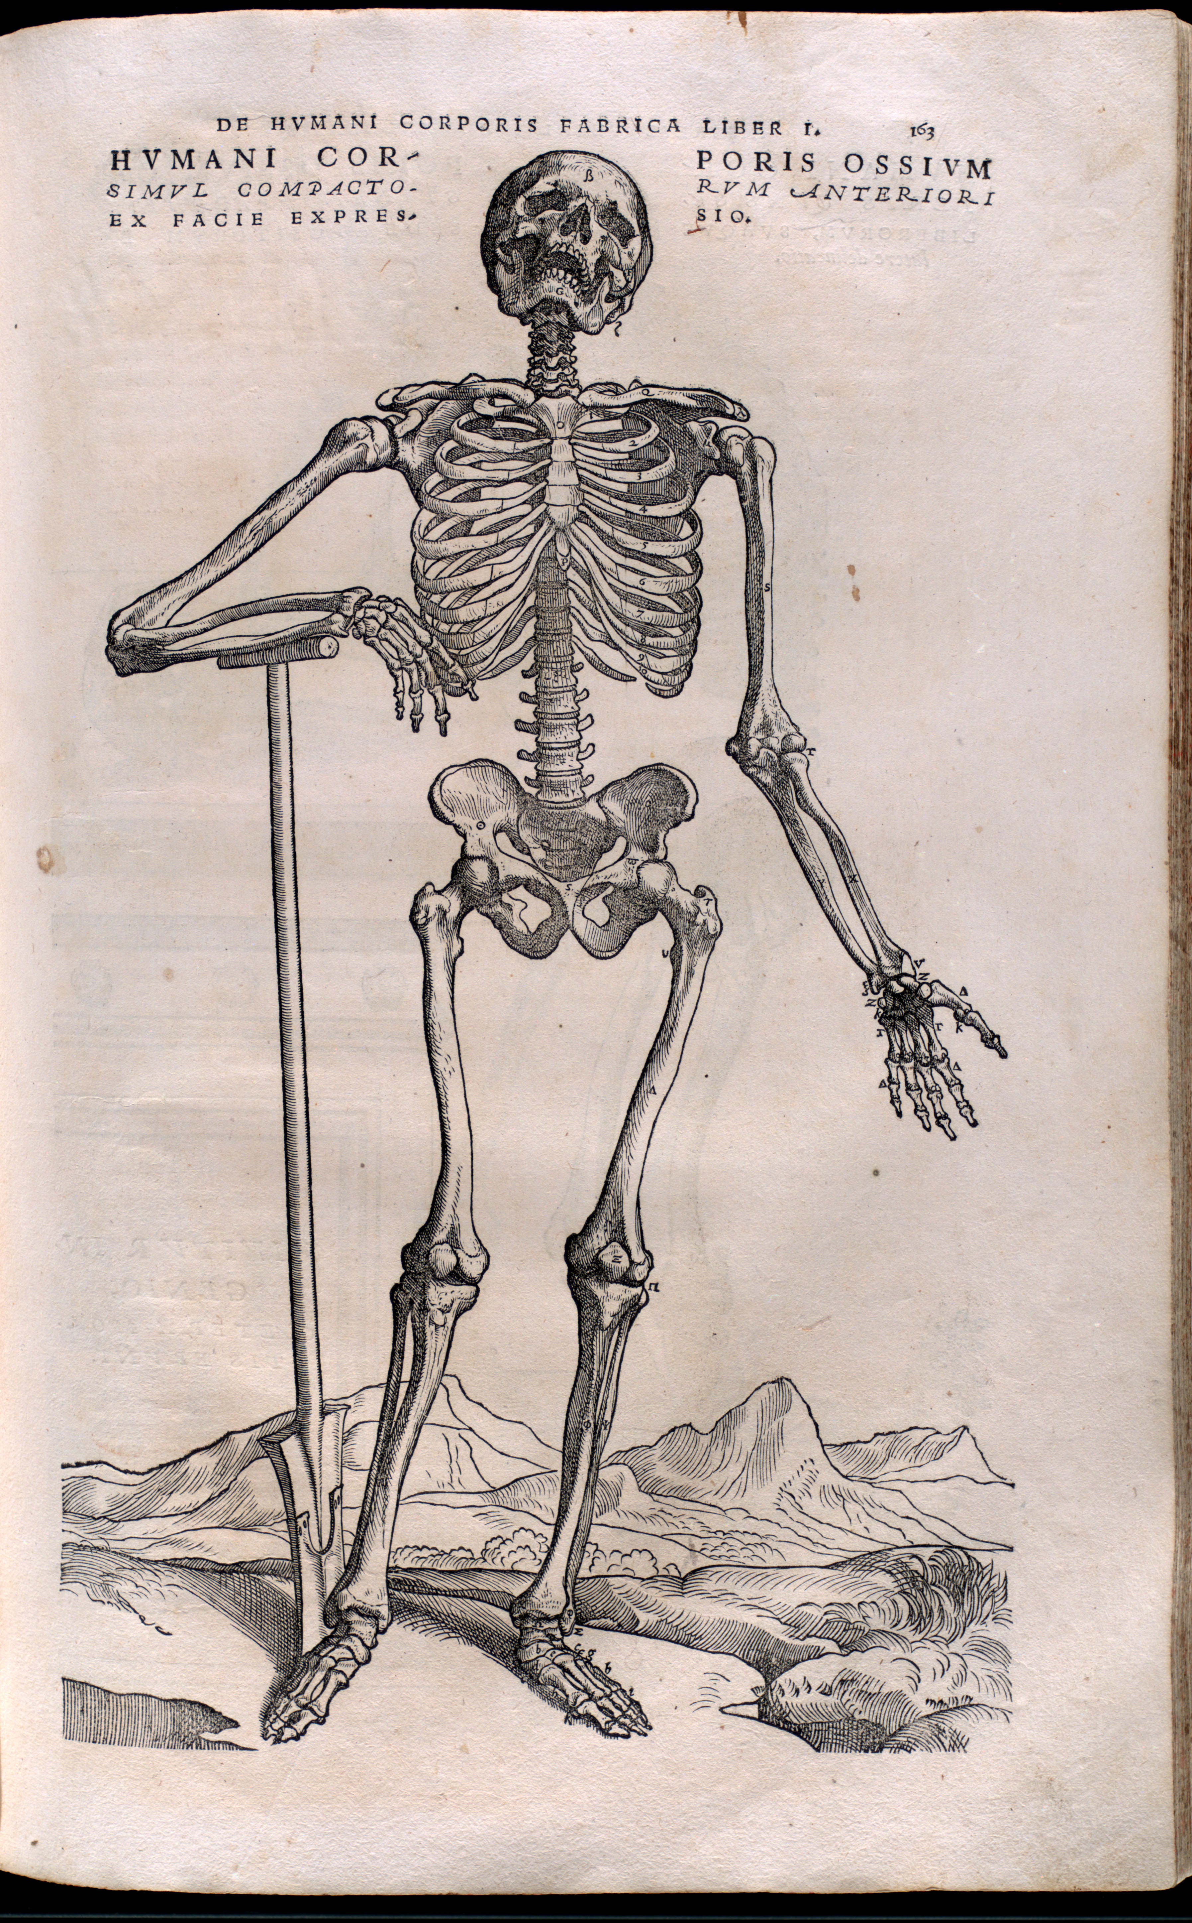

Anatomia K RBAI035 0004

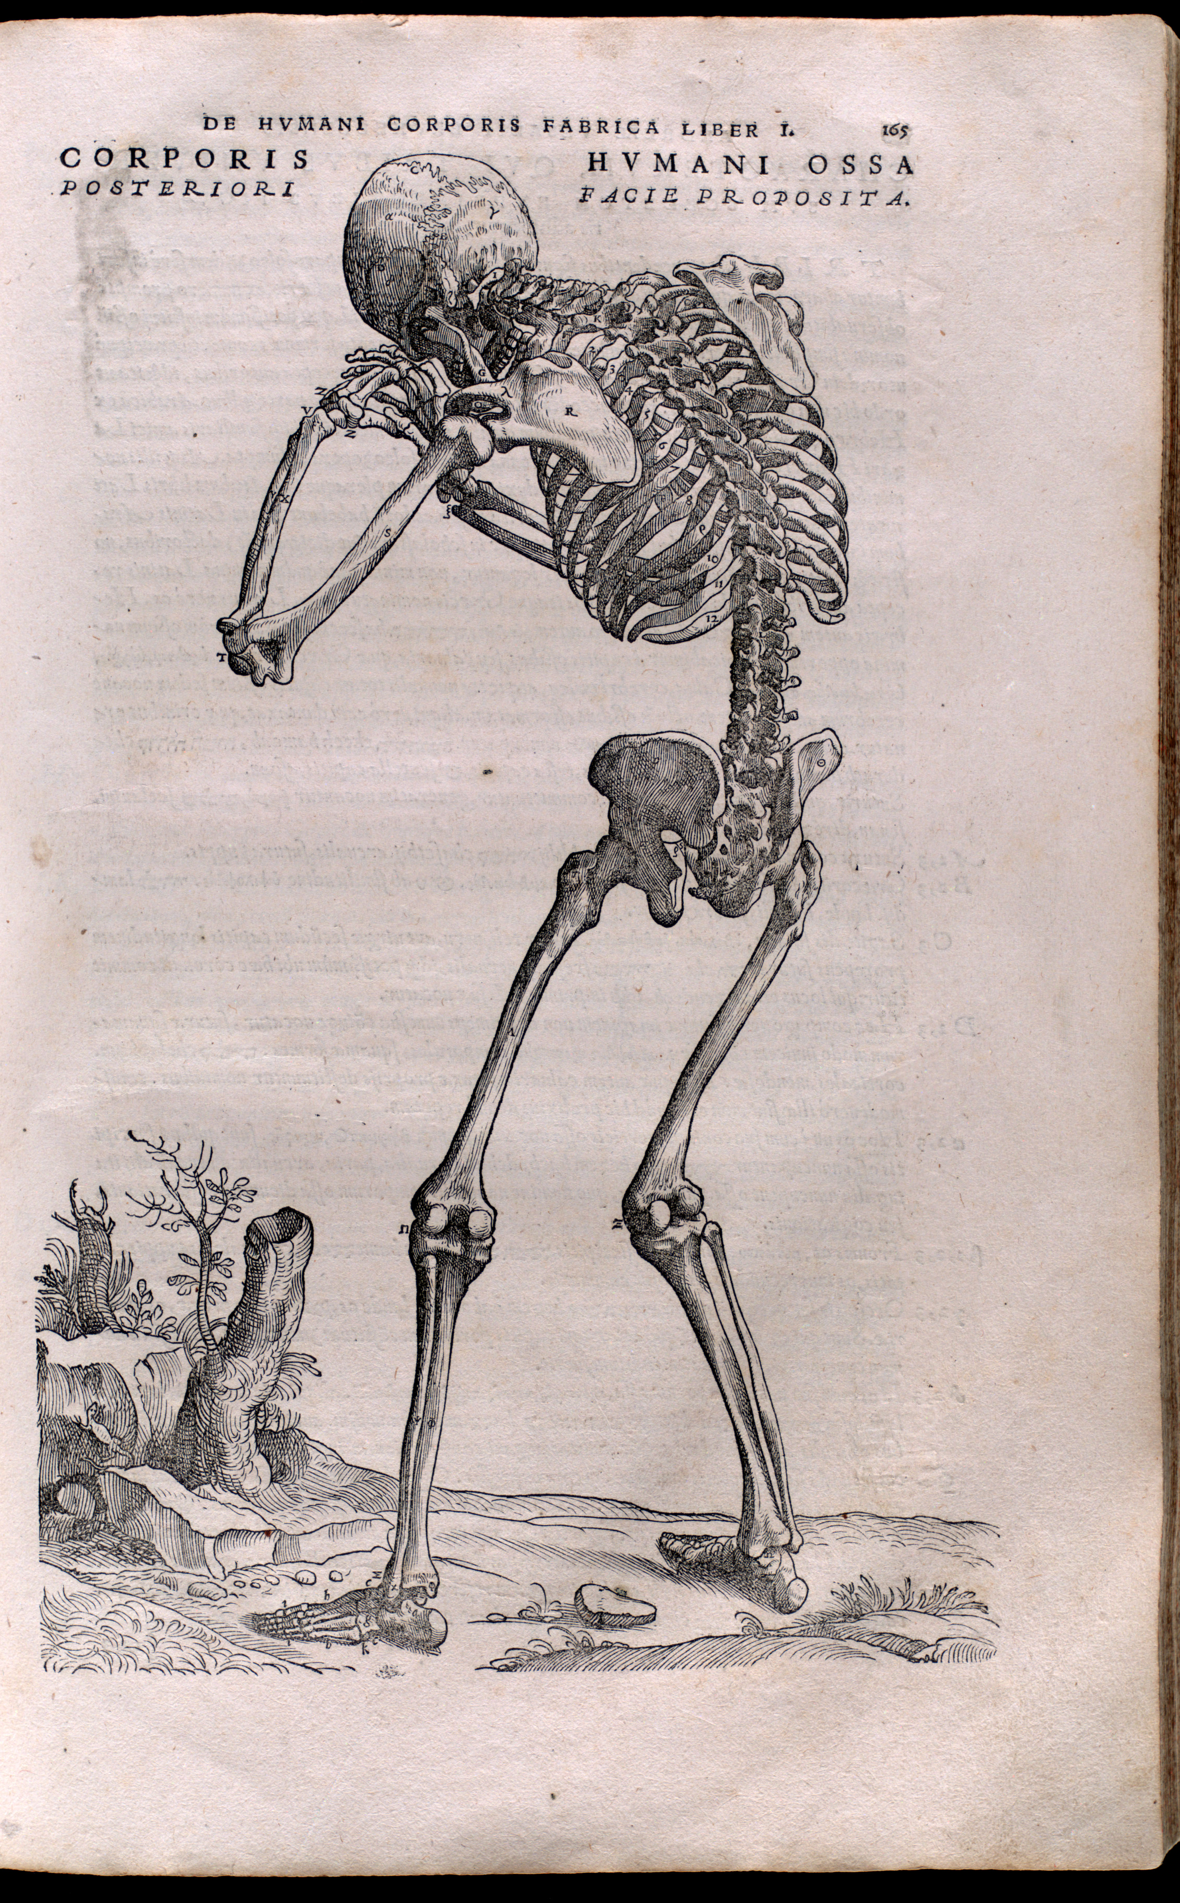

Anatomia K RBAI035 0006

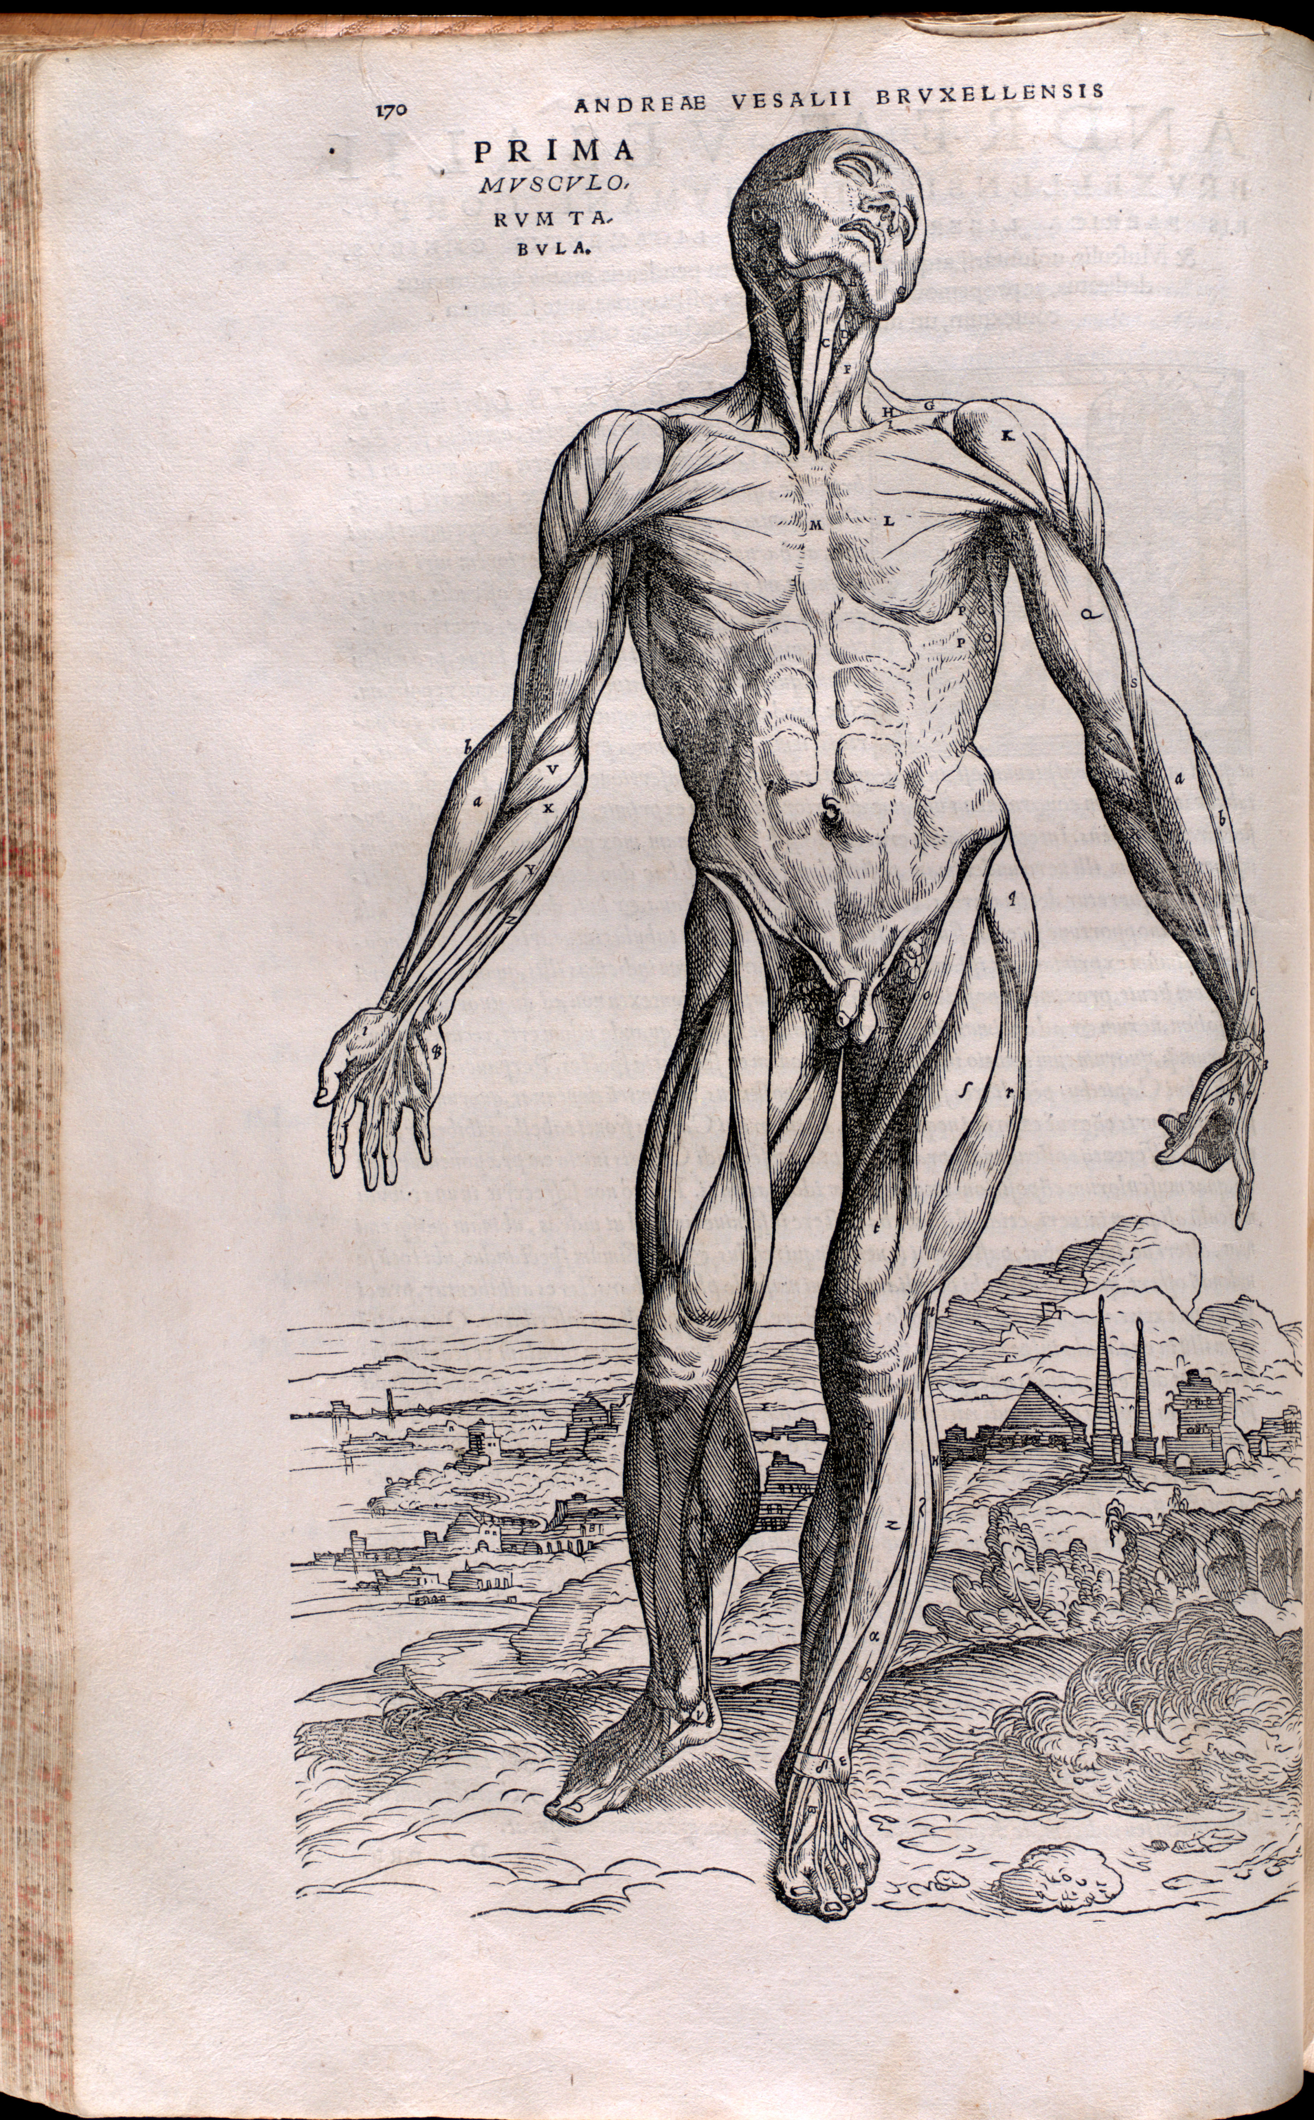

Anatomia K RBAI035 0008

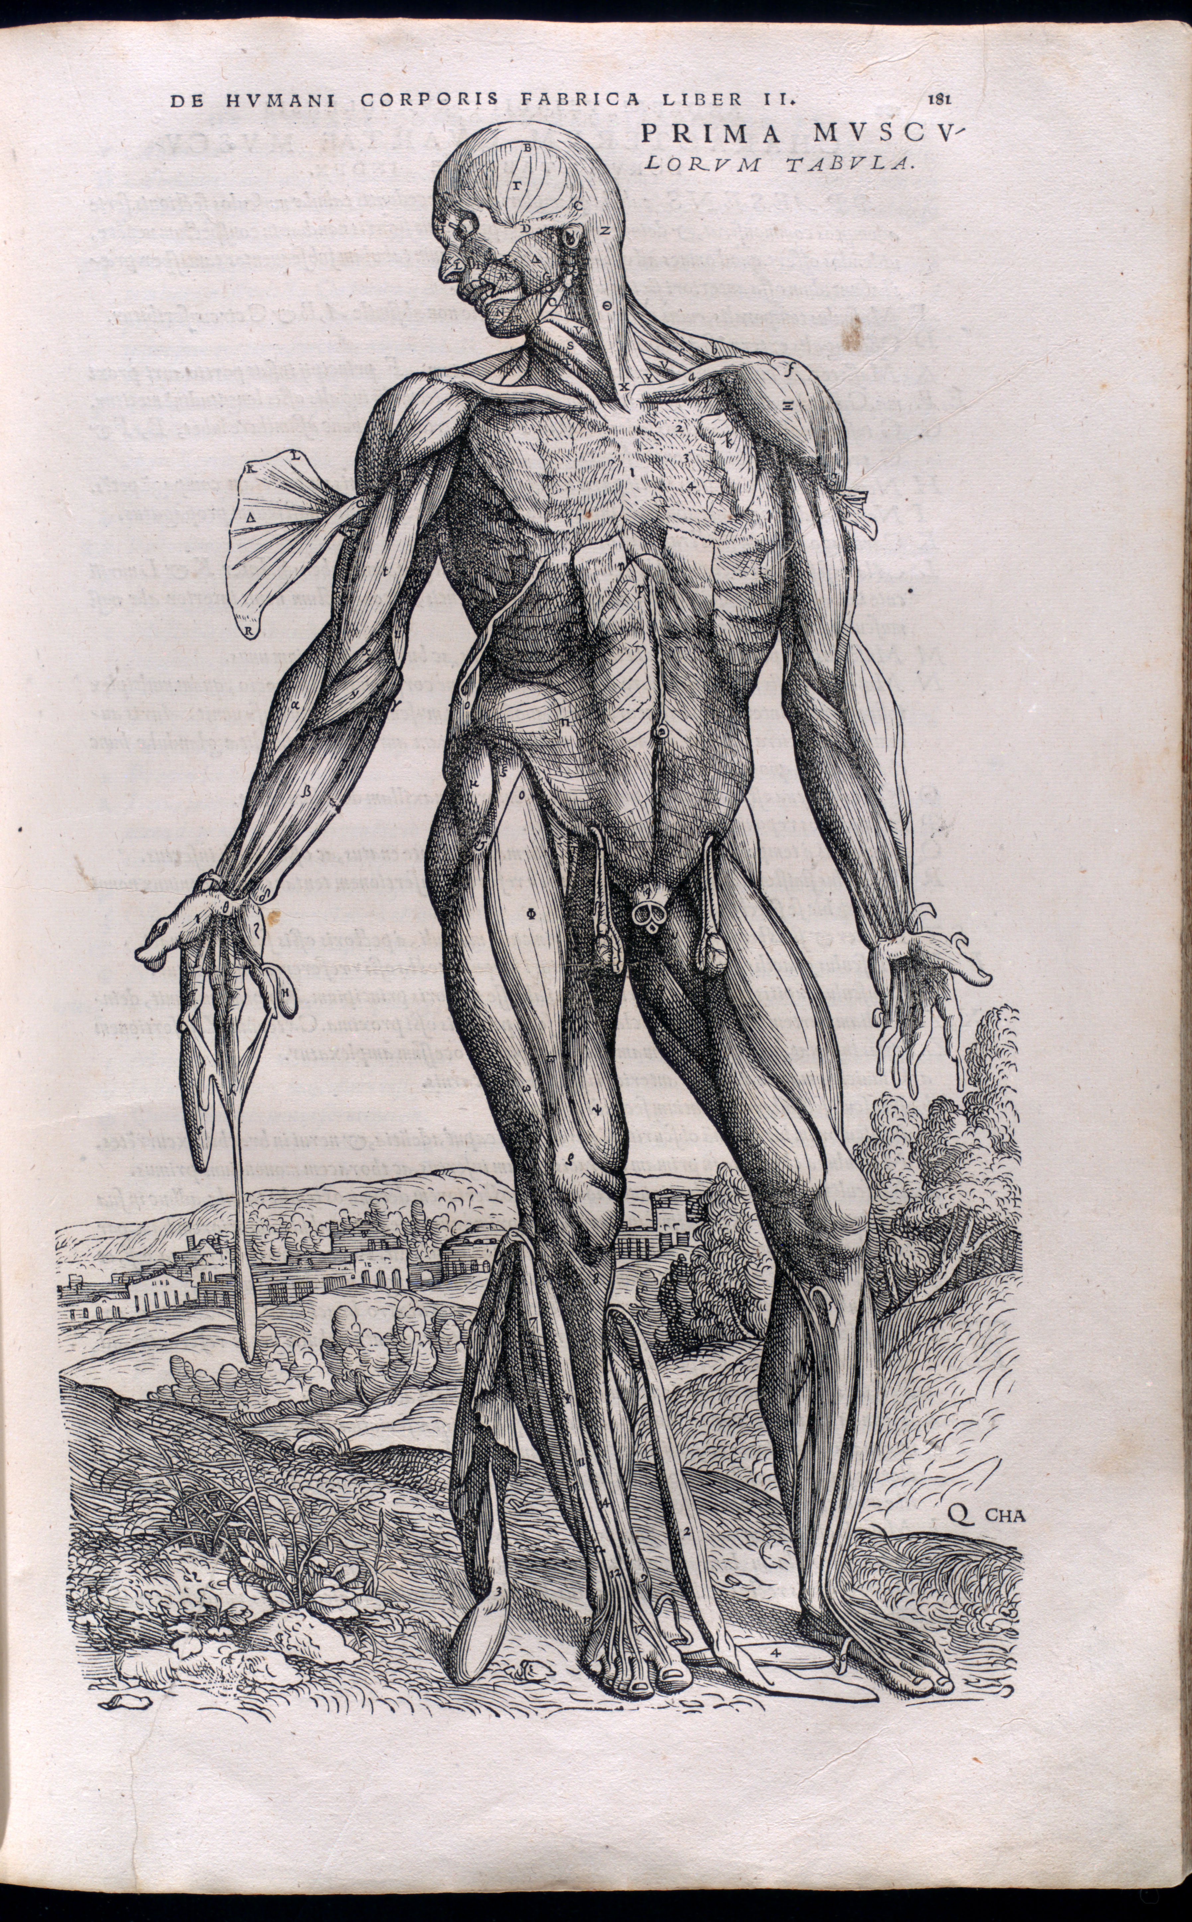

Anatomia K RBAI035 0011

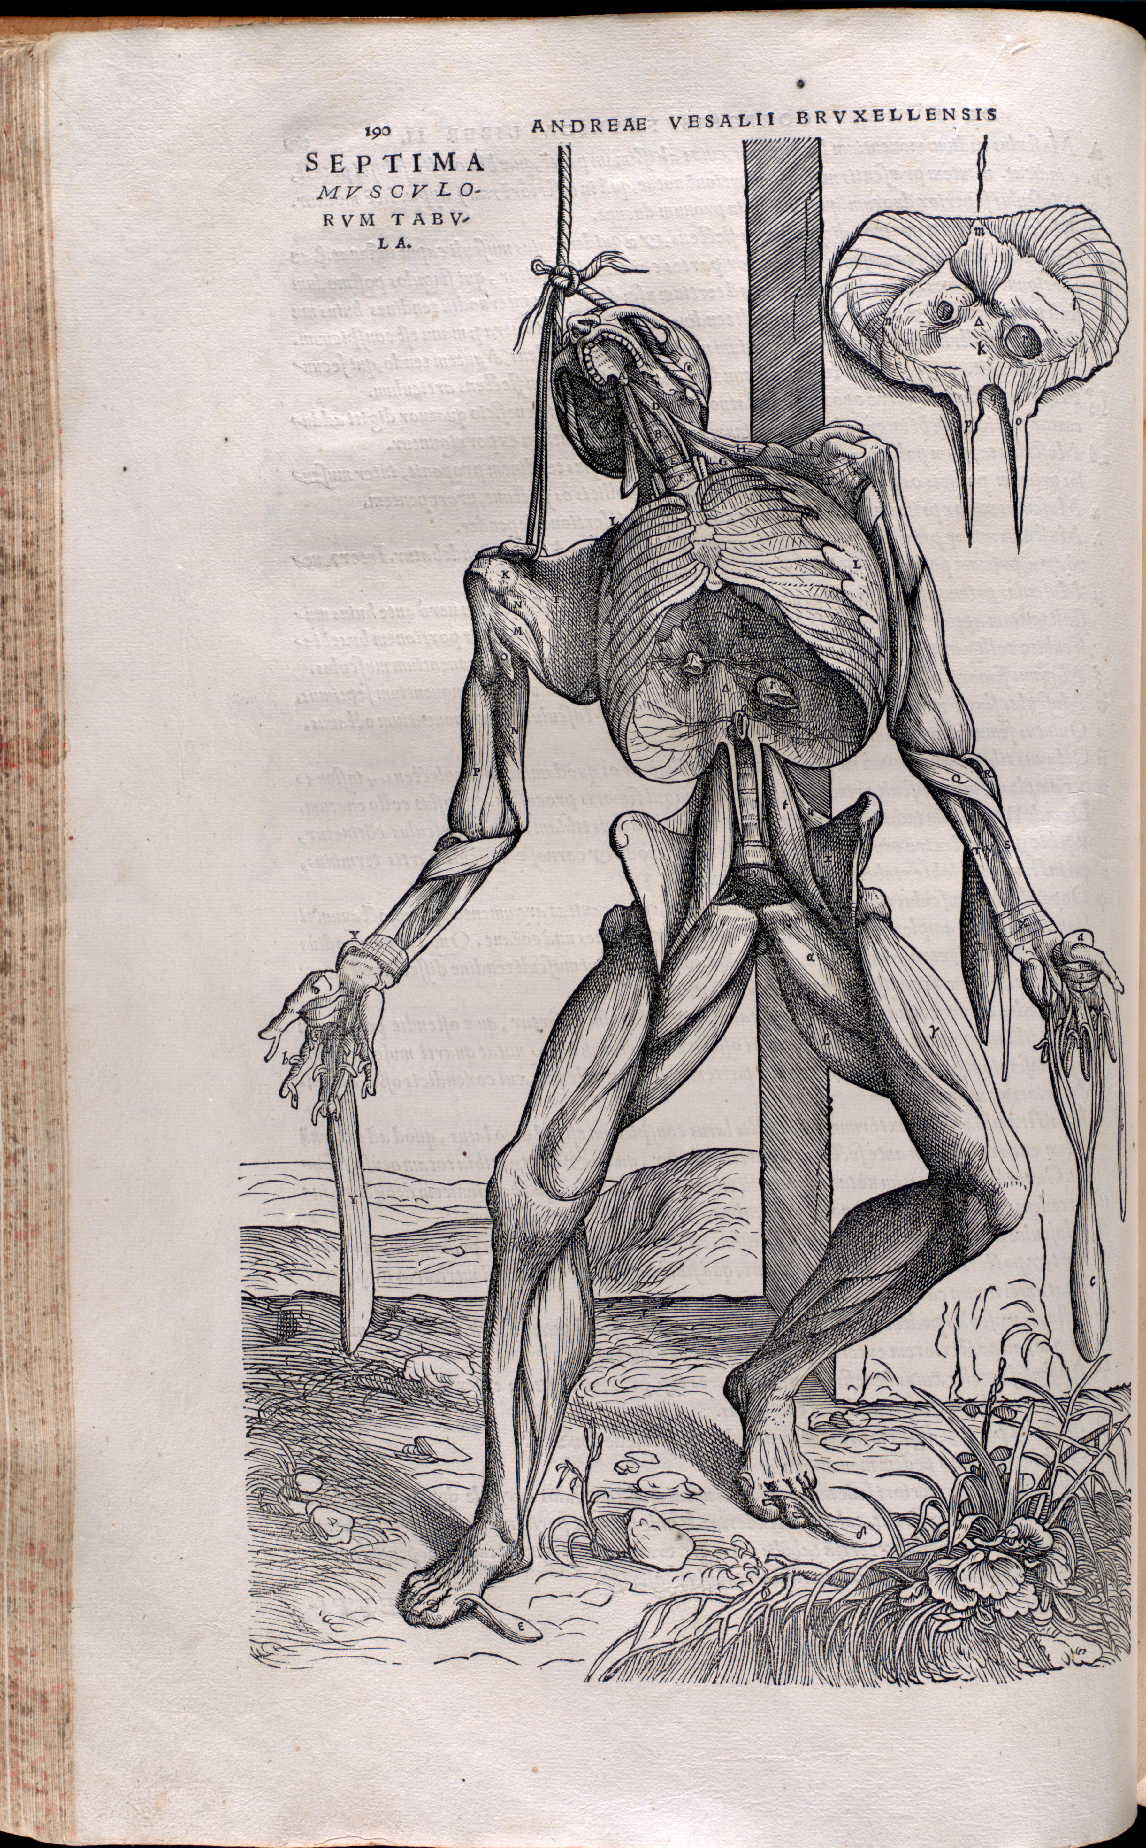

Anatomia K RBAI035 0014

* In general, see Ivanová and Holomáňová (2001).
* Musil et al. (2014) discuss his contributions to the naming of the skelatal muscles.
* Historical background: clip from BBC series [Blood and Guts](https://www.youtube.com/watch?v=qOhh-8mgTFk).

# Roots, Part III

## AC(U)-

* ‘sharp’, ‘sour’, ‘needle’ (*acus*)
* ACU-PUNCT-ure; ACU-ol-ate, beset with small prickles; ACUTI-COST-al, having projecting ribs

## ARE-

* ‘space’ (*area*)
* ARE-ola, any minute interstice or space in a tissue; or a pigmented ring surrounding some central point or space, as a nipple or a pustule, or the part of the iris enclosing the pupil; ARE-ol-et, a small areola

## AUR-

* ‘ear’ (*auris*)
* end-AUR-al, pertaining to the inner surface or part of the external auditory canal; AUR-icle, any ear-like, lobed appendage, or the external ear, or the atrium, or anterior chamber, of the heart

## CALC-

* ‘limestone’, ‘pebble’, ‘calcium’ (*calx*)
* CALC-ulus; CALCI-COLE, a plant that thrives in soils rich in calcium salts; CALCI-FIC-at-ion, the deposition of lime salts in tissue; CALC-ar-eous, containing calcium carbonate (chalky)

## CAPS-

* ‘box’ (*capsa*)
* CAPS-ule; en-CAPS-ul-at-ion, the process of surrounding a part with a capsule; de-CAPS-ul-at-ion, removal of a capsule or enveloping membrane

## CAR(N)-

* ‘flesh’ (*caro*)
* CARN-al; CARN-eous, flesh-coloured; in-CARN-at-ive, an agent which produces flesh or promotes granulation; CARNI-VOR-ous

## CUT-

* ‘skin’ (*cutis*)
* intra-CUT-aneous, within the skin substance (applied to the injection of substances into the skin); CUT-in, a substance allied to cellulose found in external layers of thickened epidermal cells

## FIBR-

* ‘fibre’ (*fibra*)
* FIBR-il, a component filament of a fibre, as of a muscle or a nerve; FIBR-in, the fibrous, insoluble protein in the network involved in blood clotting

## FOLL-

* ‘bag’ (*follis*)
* FOLLI-icle, a capsular fruit which opens on one side only, or a cavity or sheath (as an ovarian or hair follicle), or a small secretory cavity or sac (as an acinus or alveolus); peri-FOLL-icul-ar, surrounding a follicle

## FUN-

* ‘rope’, ‘cord’ (*funis*)
* FUN-ic, relating to or originating in the umbilical cord; FUNI-PENDUL-ous, suspended by a rope or cord

## LOC-

* ‘place’ (*locus*)
* LOC-al; al-LOC-ate; LOCO-MOT-ion; LOC-ellus, a small compartment of an ovary; BI-LOC-ul-ar, containing two cavities or chambers

## LUN(A)-

* ‘moon’ (*luna*)
* LUN-ate, crescent-shaped; SEMI-LUN-ar, half-moon-shaped; LUN-ette, the transparent lower eyelid of snakes

## OST-

* ‘door’, ‘opening’ (*ostium*)
* OSTIUM, any mouthlike opening, such as the opening of the fallopian tubes; OSTI-ole, the opening of a conceptacle, perithecium, stoma, or another sac, or the inhalant aperture of a sponge

## PART-

* ‘part’, ‘to divide’ (*pars*)
* PARTI-CIP-ate; PART-ic-ul-ar; BI-PART-ite, having two parts; DIGITI-PART-ite, having leaves divided in a hand-like pattern

## PED-

* ‘foot’ (*pes*)
* PED-al; im-PEDE; ex-PED-ient; PEDI-cel, any slender stalk, especially one that supports a fruiting or spore-bearing organ; SCUTI-PED, having the foot or part of the foot covered by scutella

## PELL-

* ‘skin’ (*pellis*)
* PELL-icle, a thin skin or film, such as a film on the surface of a liquid

## PLUM-

* ‘feather’ (*pluma*)
* PLUMI-GER-ous, feathered; PULVI-PLUME, a powder-down feather

## RACEM-

* ‘cluster of grapes or berries’ (*racemus*)
* RACEM-ose, arranged in a cluster, or bearing flowers in clusters; RACEM-ic acid, named from its being found in the juice of grapes

## RIM-

* ‘crack’, ‘chink’ (*rima*)
* RIM-ate, having fissures; RIM-iform, in the shape of a narrow fissure; BI-RIM-ose, having two clefts or slits

## VOR-

* ‘to eat’
* VOR-acious; HERBI-VOR-ous, living on vegetable food; FUNGI-VOR-ous, fungus-eating animals and plants; in-SECTI-VOR-ous, living on insects

# Roots, Part IV

## ANS-

* ‘jug handle’, ‘loop’ (*ansa*)
* ANSA, loop, as of certain nerves; ANSA CERVIC-alis, a nerve loop in the neck

## DIGIT-

* ‘finger’, ‘toe’ (*digitus*)
* DIGIT-ule, any small, fingerlike process; SEX-DIGIT-ate, with six fingers or toes

## FORMIC-

* ‘ant’ (*formica*)
* FORM-ic acid, a colourless acid occurring in ants and some plants; FORMI-CIDE, a substance used for destroying ants; FORMIC-at-ion, an abnormal sensation of insects crawling on the skin

## HAUST-

* ‘to draw out’, ‘to drink’
* ex-HAUST-ion; HAUST-ellum, a proboscis adapted for sucking; HAUST-orium, an organ of certain parasitic protozoa by which they attach themselves to the host

## MENT-

* ‘mind’ (*mens*)
* MENT-at-ion, the mechanism of thought, mental activity; de-MENT-ia, deterioration or loss of the intellectual faculties, the reasoning power, etc.

## NERV-

* ‘nerve’, ‘vein of insect wing or leaf’ (*nervus*)
* TRI-NERV-ate, having three veins or ribs running from the bast to the margin of a leaf; ab-NERV-al, away from a nerve (of the direction of an electric current passing through muscle fibres away from the point of entrance of a nerve)

## PECTOR-

* ‘breast’ (*pectus*)
* PECTOR-al, pertaining to the chest, in the chest region; MEDIO-PECTOR-al, applies to the middle part of the sternum; ex-PECTOR-at-ion, ejection of material from the mouth

## PIL-

* ‘hair’ (*pilus*)
* PIL-ose, hairy, downy; PILI-FER-ous, bearing or producing hair; PILI-MIC-at-ion, the passing of urine containing hairlike filaments

## PISC-

* ‘fish’ (*piscis*)
* PISC-ine, of, relating to, having the characteristics of fish; PISCI-VOR-ous, fish-eating

## PRESS-

* ‘to press’
* de-PRESS-ion, im-PRESS-ion, re-PRESS, op-PRESS-ion; de-PRESSO-MOT-or, any nerve which lowers muscular activity

## ROD-, ROS-

* ‘to gnaw’
* ROD-ent; cor-ROS-ive, a substance which destroys organic tissue by chemical means or by inflammation; e-ROS-ion, an eating, gnawing or wearing away

## SEB-

* ‘grease’, ‘tallow’ (*sebum*)
* SEBUM, the oily secretion of the SEB-aceous glands which lubricates and protects the hair and skin; SEBO-RRHEA, a functional disease of the sebaceous glands, characterised by an excessive secretion or disturbed quality of sebum

## SENS-, SENT-

* ‘to feel’, ‘to perceive’
* SENT-ence; con-SENT; as-SENT; dis-SENT; SENS-ile, capable of affecting a sense; SENTI-ent, of cells that are sensitive and perceptive; SENS-illa, a small sense organ

## SOL-

* ‘sun’ (*sol*)
* SOL-arium; in-SOL-at-ion, exposure to the sun’s rays; SOL-ASTER-idae, a family of starfishes, typically brightly coloured and having numerous arms

## SOMN-

* ‘sleep’ (*somnus*)
* SOMNI-FACI-ent, a medicine producing sleep, a hypnotic; SOMNI-FUG-ous, driving away sleep; hyper-SOMN-ia, excessive sleepiness

## SQUAM-

* ‘scale’ (*squama*)
* SQUAMI-FER-ous, bearing scales; e-SQUAM-ate, having no scales; SQUAM-ul-ate, having minute scales

## TER(R)-

* ‘earth’ (*terra*)
* TERR-aneous, applies to land vegetation; TERRI-COL-ous, living in the earth

## UTER-

* ‘womb’ (*uterus*)
* UTER-ismus, uterine contraction of a spasmodic and painful character; UTERO-GEST-at-ion, the part of the gestation period passed in the uterus; UTRI-cle or UTRI-culus, an air bladder of aquatic plants, or the membranous sac of the ear labyrinth

## VACU-

* ‘empty’ (*vacuus*)
* VACUUM; VACU-ole, one of the spaces in cell protoplasm containing air, sap or partially digested food; VACU-ol-is-at-ion, the formation of vacuoles

## VAS-

* ‘vessel’ (*vas*)
* VASE; VAS-cul-ar, consisting of or containing vessels adapted for transmission or circulation of fluid; CARDIO-VAS-cul-ar, pertaining to the heart and blood vessels; VASO-di-LAT-ion, relaxing or enlarging the vessels